Gap Analysis:
End-of-Life Care During the Last Days and Hours, September 2011
Work Sheet

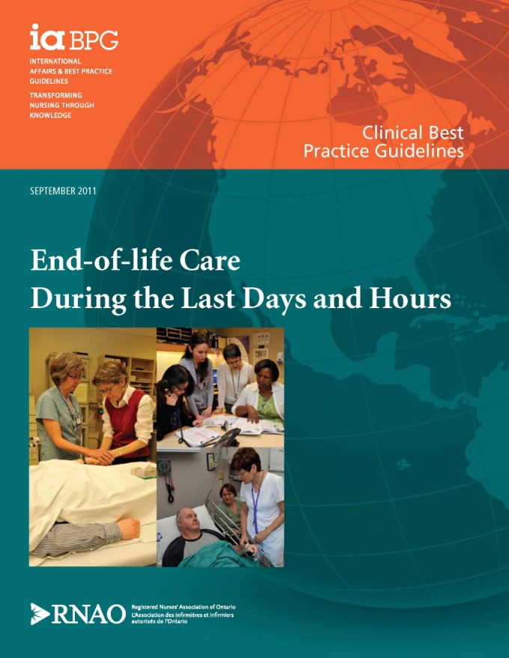
This guideline can be downloaded for free at:
http://rnao.ca/bpg/guidelines/endoflife-care-during-last-days-and-hours

The RNAO Leading Change Toolkit 3rd Edition
https://rnao.ca/leading-change-toolkit

Date Completed:
Team Members participating in the Gap Analysis:
Completion of this gap analysis allows for the annual comparison of your current practice to evidence-based practices as regulated by the MOHLTC per Fixing Long-Term Care Act, 2021 at https://www.ontario.ca/laws/statute/21f39 &
O. Reg. 246/22: GENERAL (ontario.ca)

RNAO Best Practice Guideline Recommendations |  |  |  |  | Met | Partially Met | Unmet | Notes  (Examples of what to include: is this a priority to our home, information on current practice, possible overlap with other programs or partners)
Practice Recommendations for Assessment at the End of Life
1.1 Nurses identify individuals who are in the last days and hours of life.
(Level IIa–IV Evidence)
1.1.1 Use clinical expertise, disease specific indicators and validated tools to identify these individuals.
(Level IIa–IV Evidence)
1.1.2 Understand the end-of-life trajectories.
(Level IIa–IV Evidence)
1.2 Nurses understand the common signs and symptoms present during the last days and hours of life.
(Level IIb–IV Evidence)
1.2.1 Common signs of imminent death, may include, but are not limited to:
- Progressive weakness;  - Bedbound state;  - Sleeping much of the time;  - Decreased intake of food and fluid;  - Darkened and/or decreased urine output;  - Difficulty swallowing (dysphagia); |  | - Delirium not related to reversible causes;  - Decreased level of consciousness not related to other causes;  - Noisy respiration/excessive respiratory tract secretion;  - Change in breathing pattern (Cheyne-Stokes respiration, periods of apnea); and  - Mottling and cooling extremities.
(Level IIb–IV Evidence)
1.3 Nurses complete a comprehensive, holistic assessment of individuals and their families based on the Canadian Hospice Palliative Care Association Domains of Care, which include the following:
- Disease management;  - Physical;  - Psychological;  - Spiritual; | - Social;  - Practical;  - End-of-life care/death management; and  - Loss, grief.
(Level IIb–IV* Evidence)
1.3.1 Include information from multiple sources to complete an assessment. These may include proxy source such as the family and other health-care providers.
(Level IIb–IV* Evidence)
1.3.2. Use evidence-informed and validated symptom assessment and screening tools when available and relevant.
(Level IIb–IV* Evidence)
1.3.3. Reassess individuals and families on a regular basis to identify outcomes of care and changes in care needs.
(Level IIb–IV* Evidence)
1.3.4 Communicate assessments to the interprofessional team.
(Level IIb–IV* Evidence)
1.3.5 Document assessments and outcomes.
(Level IIb–IV* Evidence)
1.4 Nurses:
- Reflect on and are aware of their own attitudes and feelings about death;
- Assess individuals’ preferences for information;
- Understand and apply the basic principles of communication in end-of-life care;.
- Communicate assessment findings to individuals(if possible and desired) and the family on an ongoing basis;
- Educate the family about the signs and symptoms of the last days and hours of life, with attention to their ; faith and spiritual practices; age-specific needs; developmental needs; cultural needs; and
- Evaluate the family’s comprehension of what is occurring during this phase.
(Level III–IV Evidence)
Practice Recommendations for Decision Support at the End of Life
2.1. Nurses recognize and respond to factors that influence individuals and their families’ involvement in decision-making.
(Level Ib, IV, IV* Evidence)
2.2. Nurses support individuals and families to make informed decisions that are consistent with their beliefs, values and preferences in the last days and hours of life.
(Level Ia – IV* Evidence)
Practice Recommendations for Care and Management at the End of Life
3.1 Nurses are knowledgeable about pain and symptom management interventions to enable individualized care planning.
(Level III–IV Evidence)
3.2 Nurses advocate for and implement individualized pharmacologic and non-pharmacologic care strategies.
(Level Ia–IV Evidence)
3.3. Nurses educate and share information with individuals and their families regarding:
- Reconciliation of medications to meet the individual’s current needs and goals of care;  - Routes and administration of medications;  - Potential symptoms;  - Physical signs of impending death; |  |  |  | - Vigil practices;  - Self care strategies;  - Identification of a contact plan for family when death has occurred; and  - Care of the body after death.
(Level Ib–III Evidence)
3.4 Nurses use effective communication to facilitate end of life discussions related to:
- Cultural and spiritual values, beliefs and practices;  - Emotions and fears;  - Past experiences with death and loss;  - Clarifying goals of care; |  |  | - Family preference related to direct care involvement;  - Practical needs;  - Informational needs;  - Supportive care needs;  - Loss and grief; and  - Bereavement planning.
(Level III Evidence)
Education Recommendations
4.1. Entry to practice nursing programs and post-registration education incorporate specialized end-of-life care content including:
- Dying as a normal process including the social and cultural context of death and dying, dying trajectories and signs of impending death;
- Care of the family (including caregiver);
- Grief, bereavement and mourning;
- Principles and models of palliative care;
- Assessment and management of pain and other symptoms(including pharmacologic and non-pharmacologic approaches);
- Suffering spiritual/existential issues and care;
- Decision-making and advance care planning;
- Ethical issues;
- Effective and compassionate communication;
- Advocacy and therapeutic relationship-building;
- Interprofessional practice and competencies;
- Self-care for nurses, including coping strategies and self-exploration of death and dying;
- End-of-Life issues in mental health, homelessness and the incarcerated;
- The roles of grief and bereavement educators, clergy, spiritual leaders and funeral directors; and
- Knowledge of relevant legislation.
(Level Ia–III Evidence)
4.2 Successful education in end-of-life care includes specific attention to the structure and process of learning activities and incorporates:
- Small group learning;
- Dyadic and experiential learning approaches;
- Integration and consolidation of theory and practice;
- Opportunities to practice the skills and competencies acquired;
- Constructive feedback and/or reflection on acquired knowledge, skills and competencies; and
- Contact with knowledgeable and supportive clinical supervisors and mentors.
(Level Ib–III Evidence)
Organization & Policy Recommendations
5.1 Models of care delivery support the nurse, individual and family relationship.
(Level III–IV Evidence)
5.2 Organizations recognize that nurses’ well-being is a critical component of quality end-of-life care and adopt responsive strategies.
(Level III–IV Evidence)
5.3 Organizations providing end-of-life care demonstrate evidence of a philosophy of palliative care based on the Canadian Hospice Palliative Care Association’s The model to Guide Hospice Palliative Care.
(Level III–IV Evidence)
5.4 Nursing best practice guidelines can be successfully implemented only when there are adequate planning, resources, organizational and administrative supports, as well as appropriate facilitation. Organizations may wish to develop a plan for implementation that includes:
- An assessment of organization readiness and barriers to implementation.
- Involvement of all members (whether in a direct or indirect supportive function) who will contribute to the implementation process.
- Dedication of a qualified individual to provide the support needed for the education and implementation process.
- Opportunities for reflection on personal and organizational experience in implementing guidelines.
(Level IV Evidence)

